Members

Joseph Kaku

Lindsay Garner

Josh Herring

Image Links

<https://encrypted-tbn0.gstatic.com/images?q=tbn:ANd9GcTIABC2mlIIMGO0RryBNku1HjNkmvhURY92fQ&usqp=CAU>

<https://encrypted-tbn0.gstatic.com/images?q=tbn:ANd9GcT5IJPNs1PyAZnuOh_vdwtUgCQc5pl5eefCCw&usqp=CAU>

<https://encrypted-tbn0.gstatic.com/images?q=tbn:ANd9GcQhYGoAm1Iuzuu7o_vJOD07JeAK6sFnmTqYRsIBZ3ekrzkvr60_jaHVtPLC3mK4xoN3a4g&usqp=CAU>

Fonts

Headers

<https://fonts.google.com/specimen/Yusei+Magic?query=magic>

Body

<https://fonts.google.com/specimen/Merriweather>

Description

The idea for our web page is that as we scroll down the webpage the sun will start in

the center then fade to the side as it and the background changes color from warm

daytime colors to sunset colors. Then it will change into nighttime colors as the

moon comes back up. If we are unable to change it with the scroll, then we will

just have the animation slowly play in the back-round. Throughout the animation

the background is all static, but the text will scroll up instead of the background

scrolling.

Small Wireframe

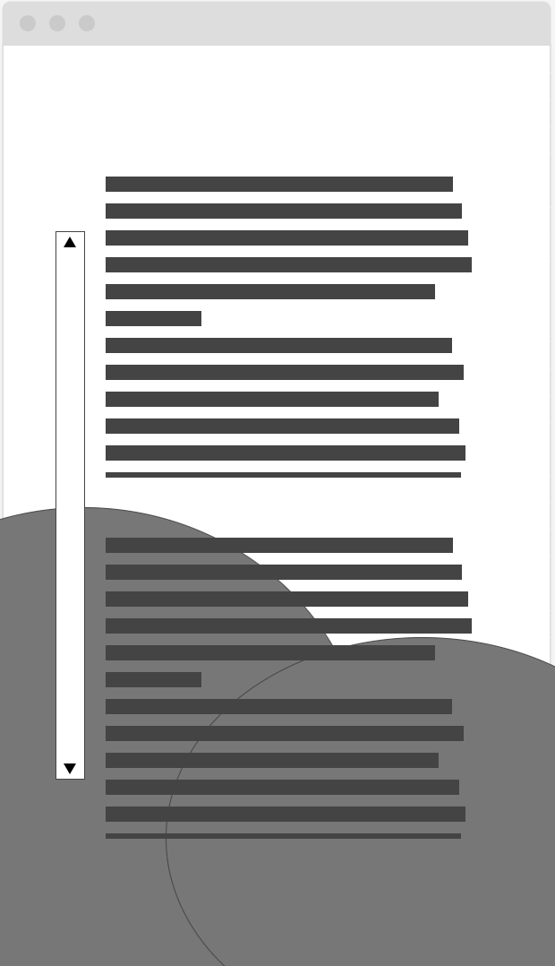

Large Wireframe

